**Image Registration using pystackreg library in Python :**

→ pyStackReg is used to align (register) one or more images to a common reference image, as is required usually in time-resolved fluorescence or wide-field microscopy.

→ pyStackReg provides the following five types of distortion:

* translation
* rigid body (translation + rotation)
* scaled rotation (translation + rotation + scaling)
* affine (translation + rotation + scaling + shearing)
* bilinear (non-linear transformation; does not preserve straight lines)

→ Documentation link of pystackreg : <https://pystackreg.readthedocs.io/>

→ It uses functionality from ImageJ.

**(1) Read our images :**

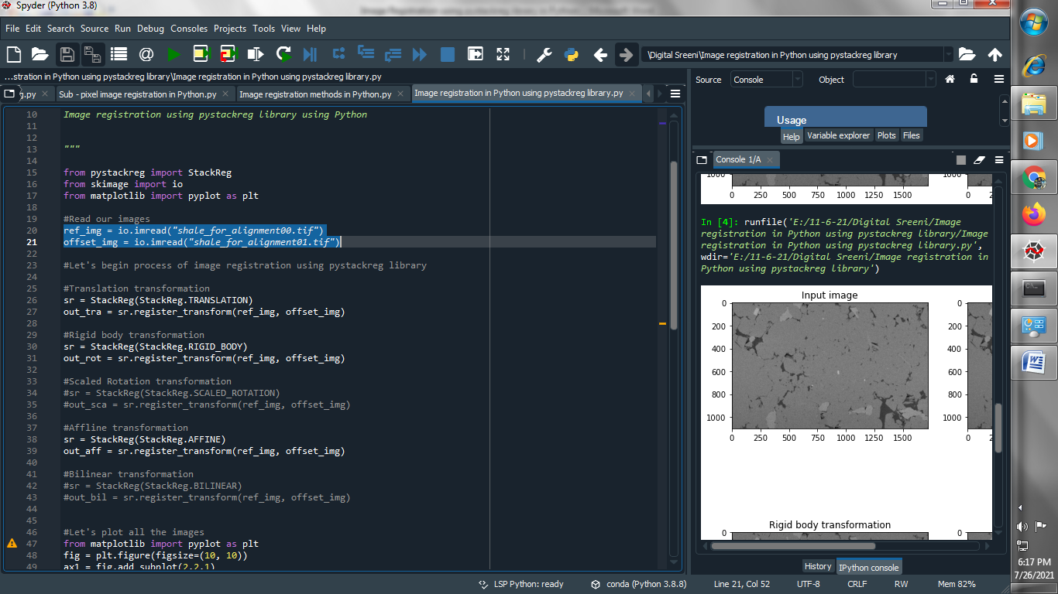

**→ Let's begin process of image registration using pystackreg library**

**(2) Apply Translation transformation :**

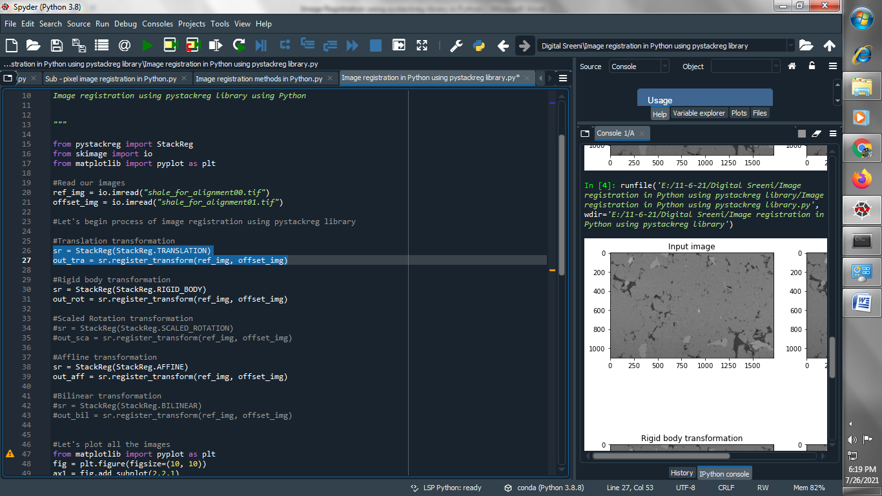

**(3) Apply Rigid body transformation :**

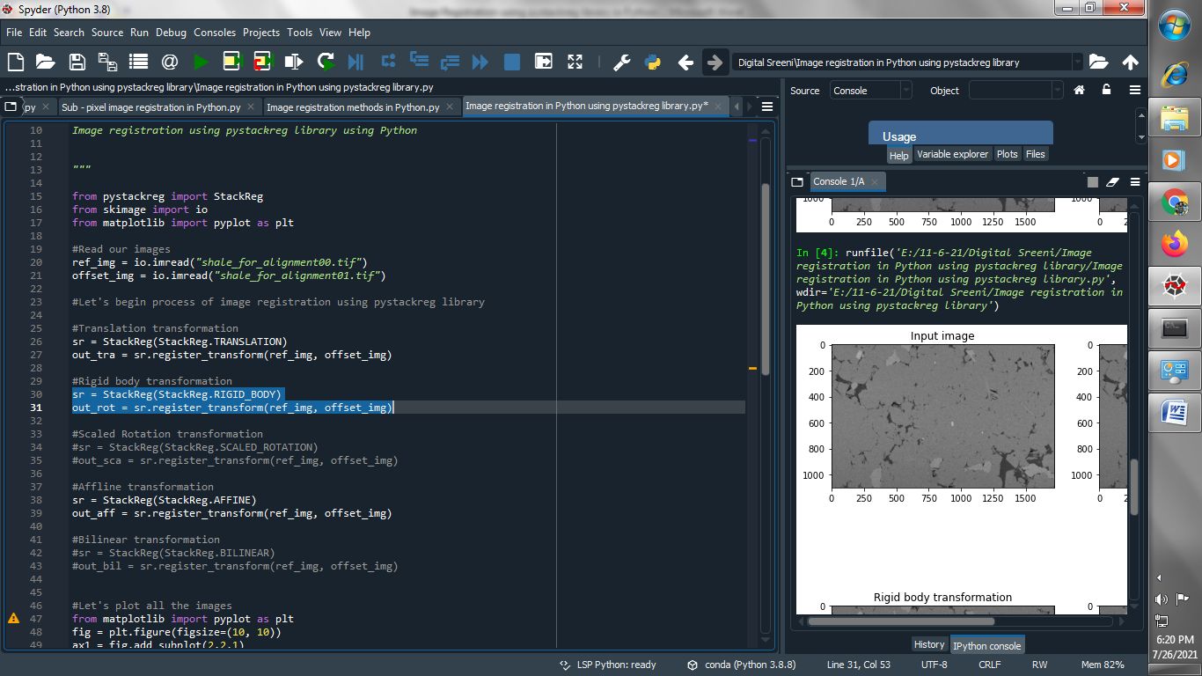

**(4) Apply Scaled Rotation transformation :**

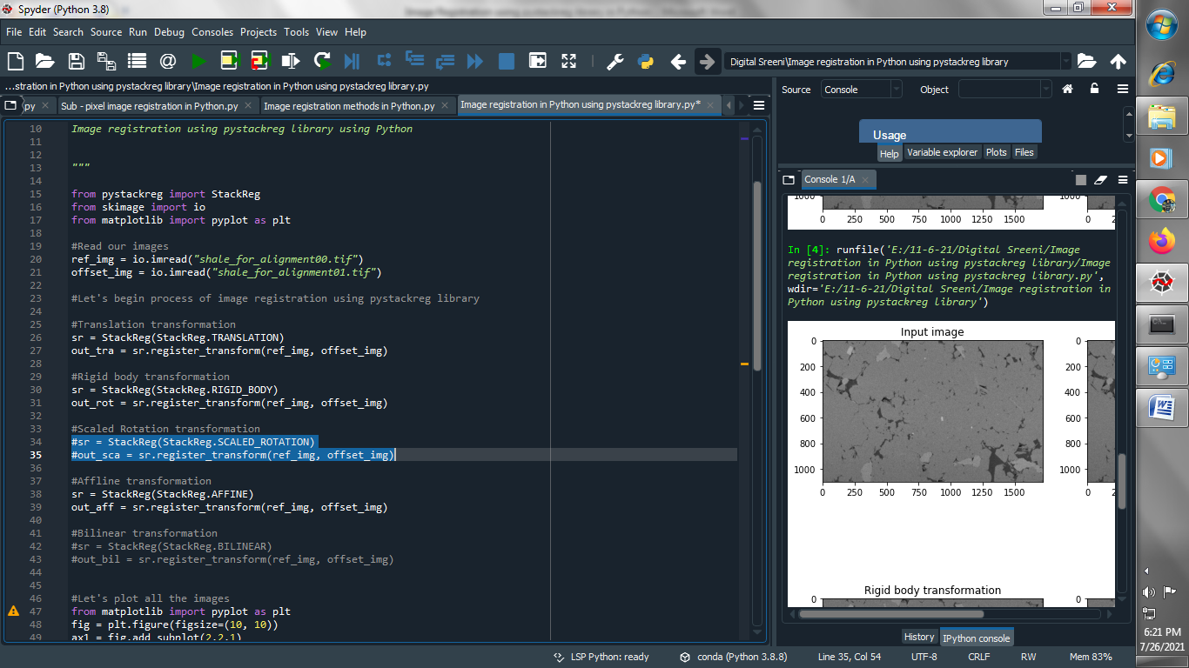

**(5) Apply Affline transformation :**

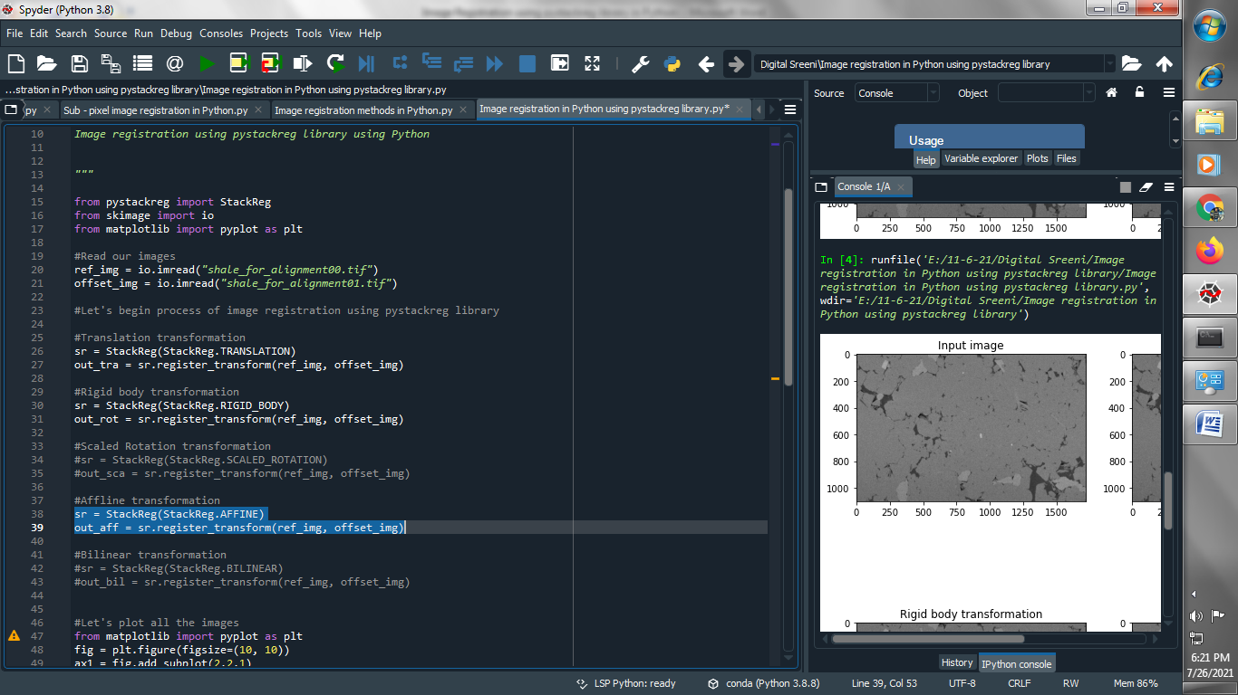

**(6) Apply Bilinear transformation :**

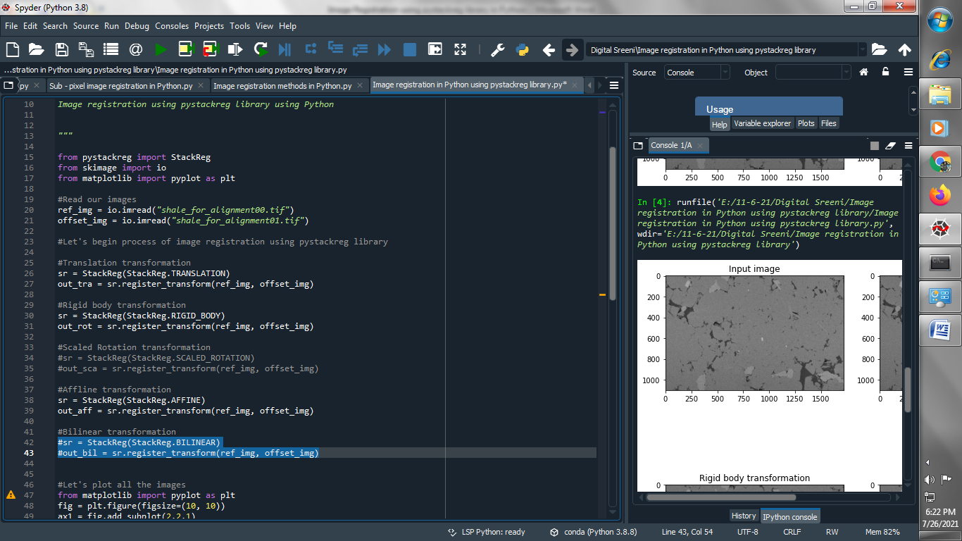

**(7) Let’s plot all the transformation of image registration :**

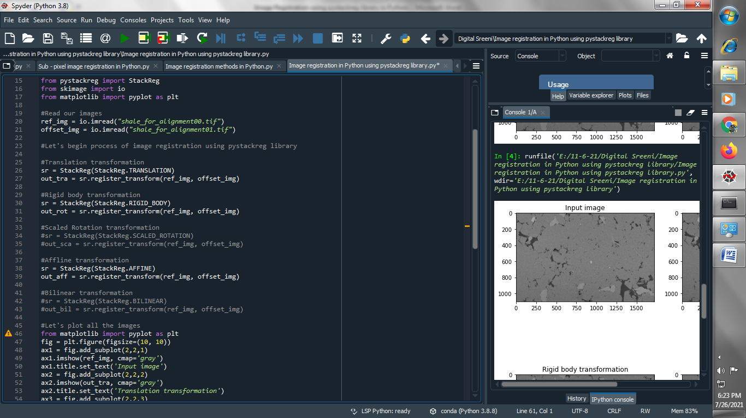

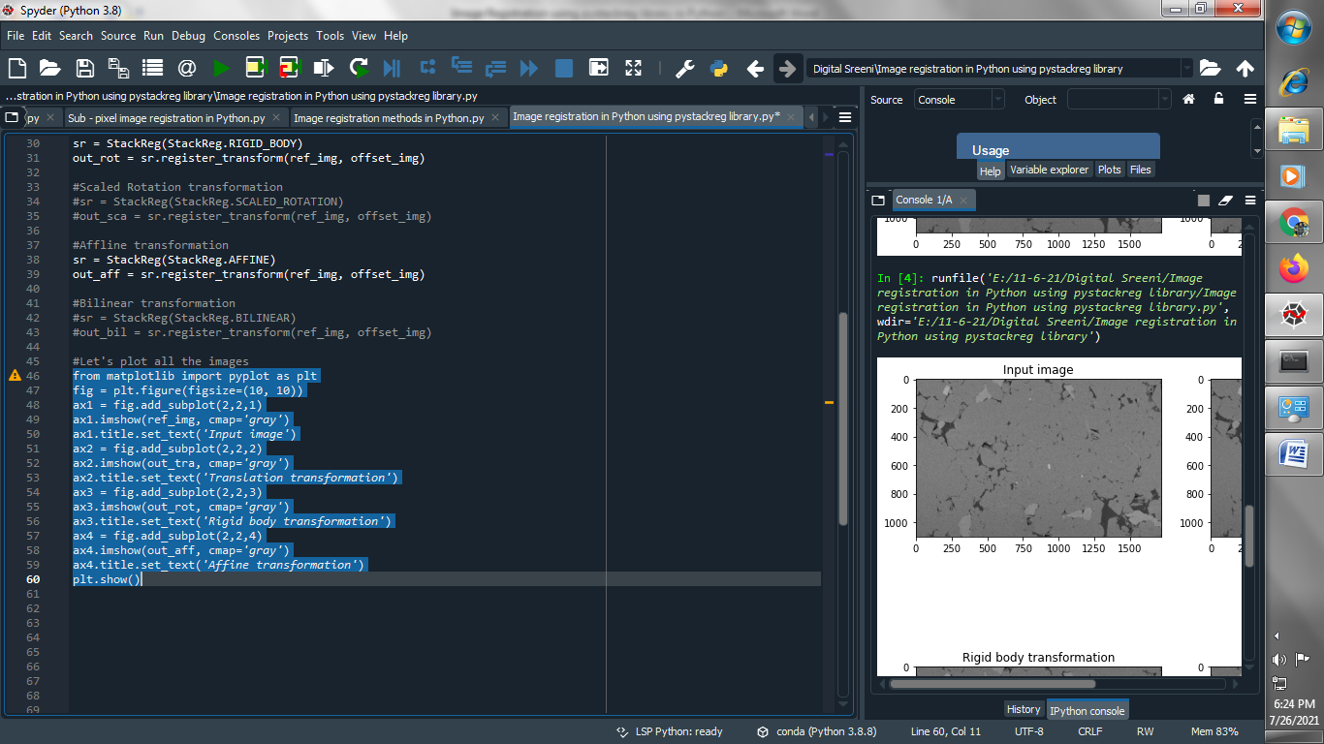

**Output :  
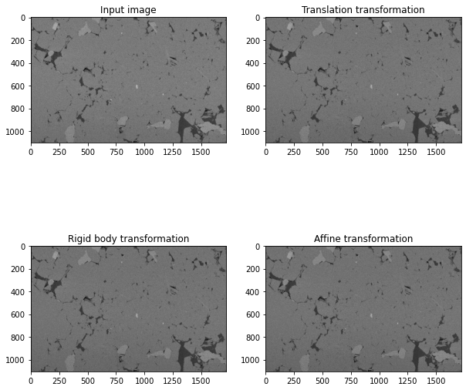**

**################################################################################**

**→ After the execution of above I realize that single image doesn't make sense for this example. So Let us look at the stack for multiple images :**

**(1) Let's create a tiff stack image from individual images :**

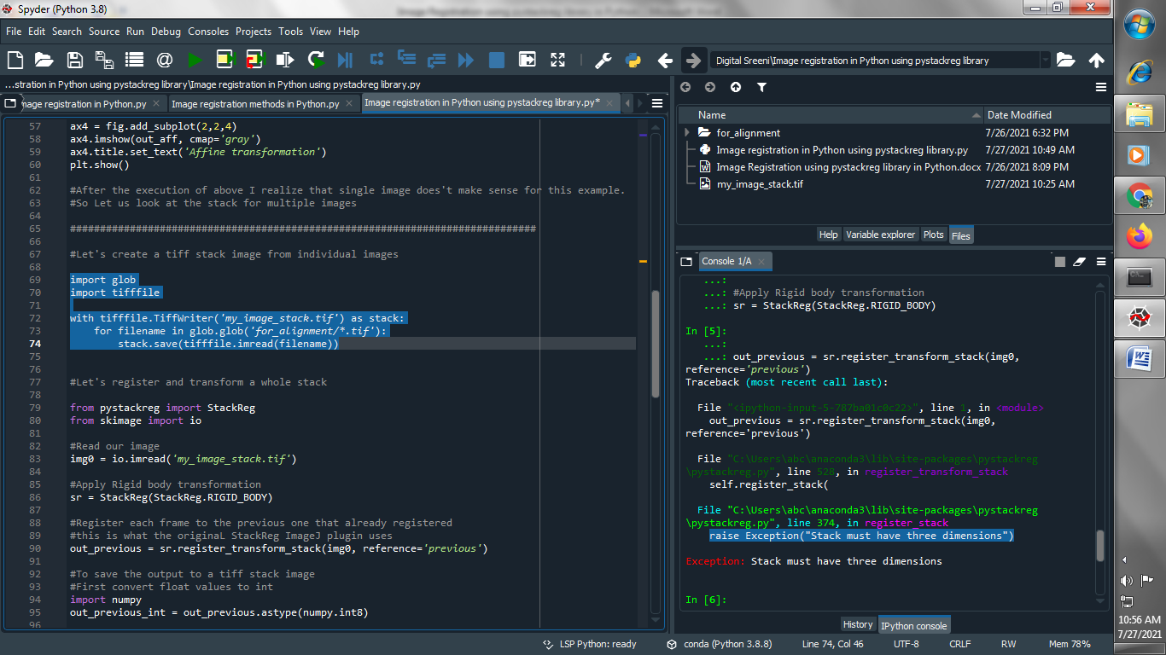

**(2) Let's register and transform a whole stack so first of all read our stack image :**

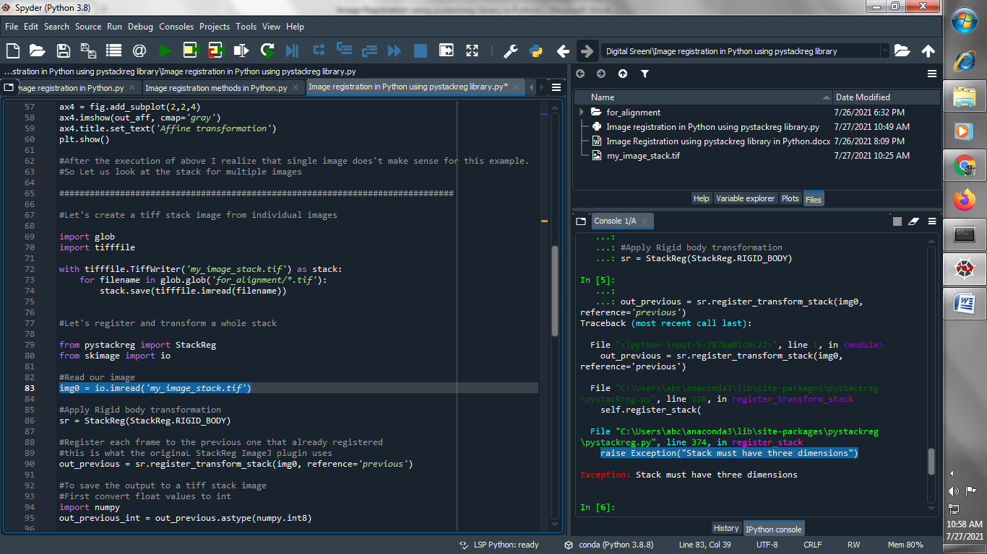

**(3) Apply Rigid body transformation :**

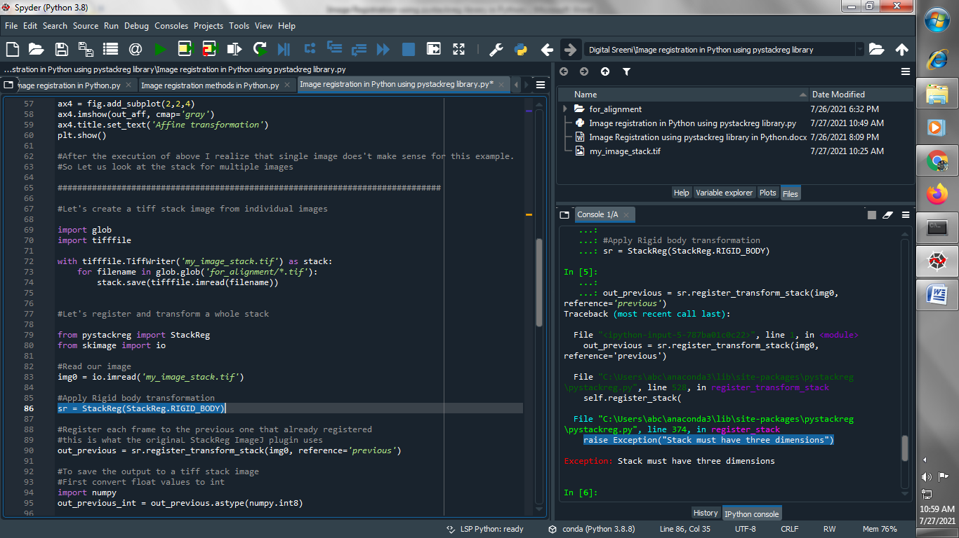

**(4) Register each frame to the previous one that already registered :**

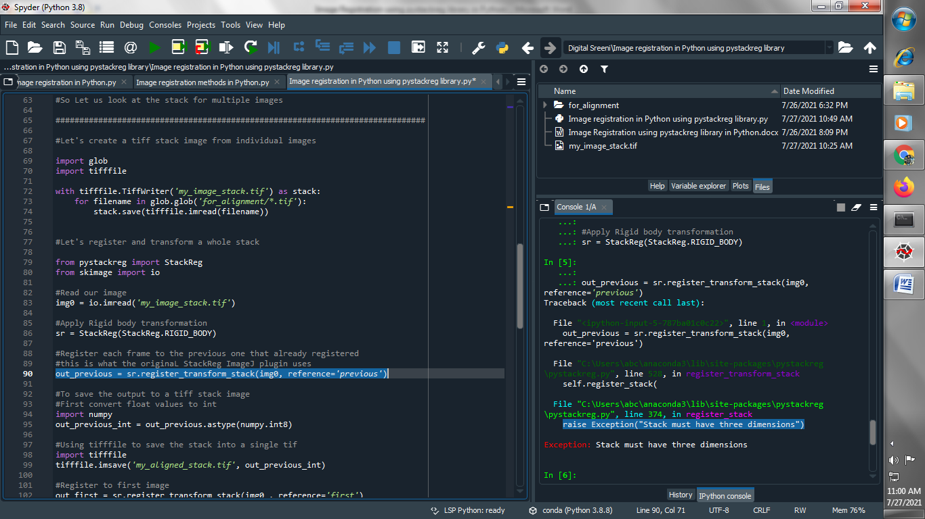

**(5) To save the output to a tiff stack image First convert float values to int :**

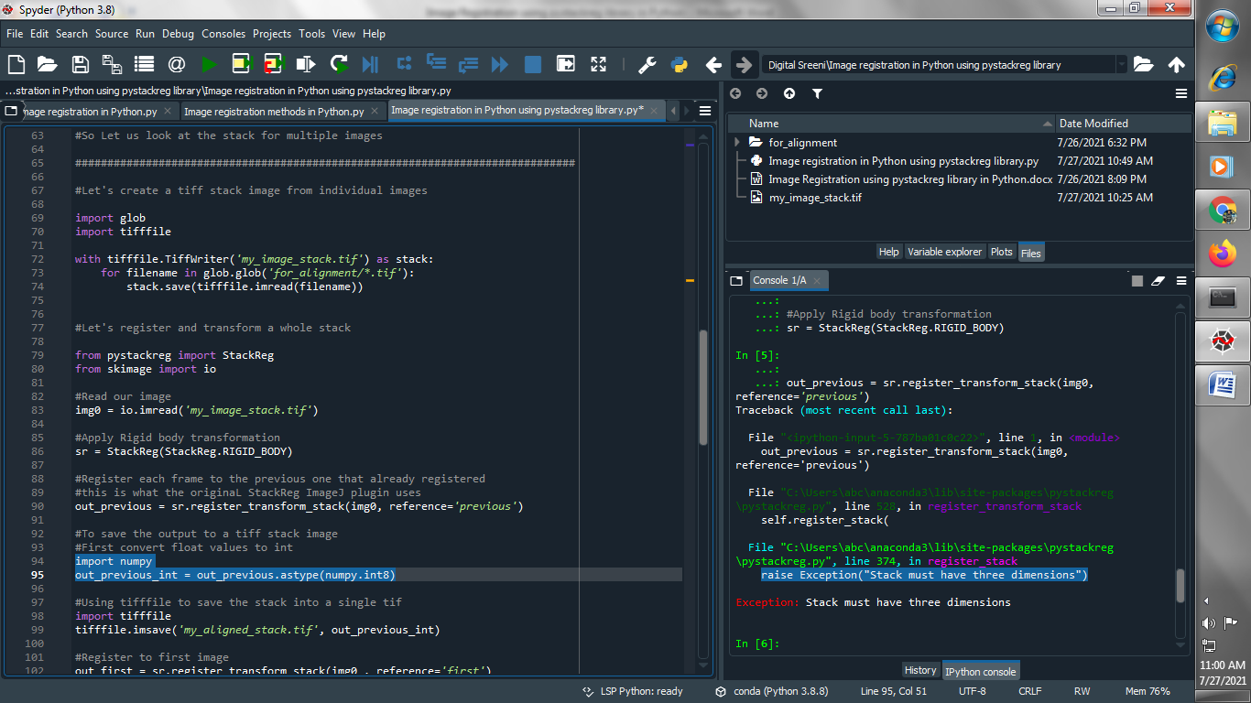

**(6) Using tifffile to save the stack into a single tif :**

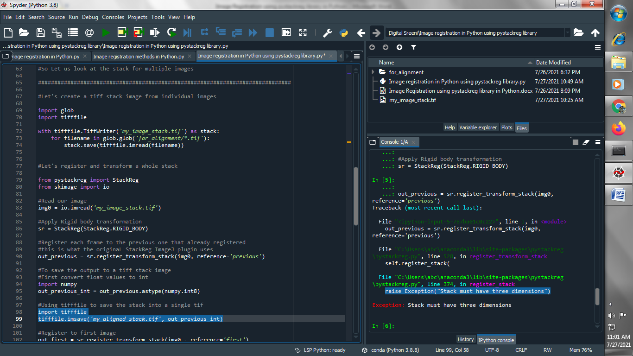

**(7) Register to first image :**

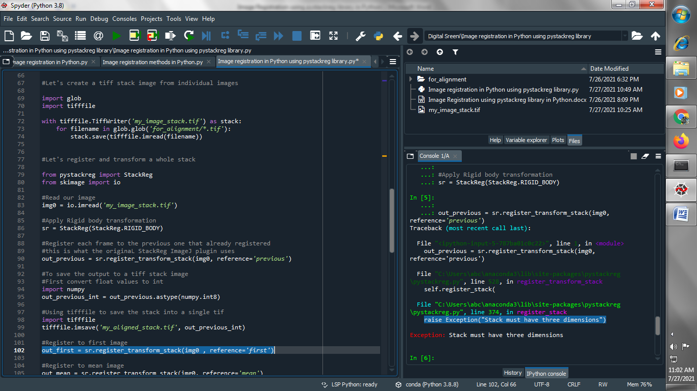

**(8) Register to mean image :**

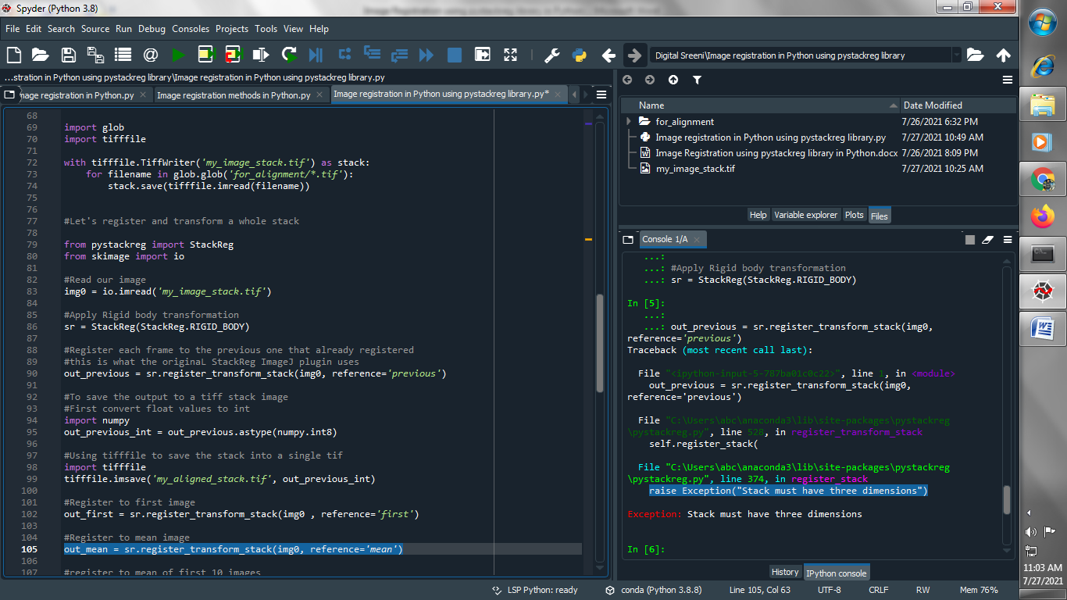

**(9) register to mean of first 10 images :**



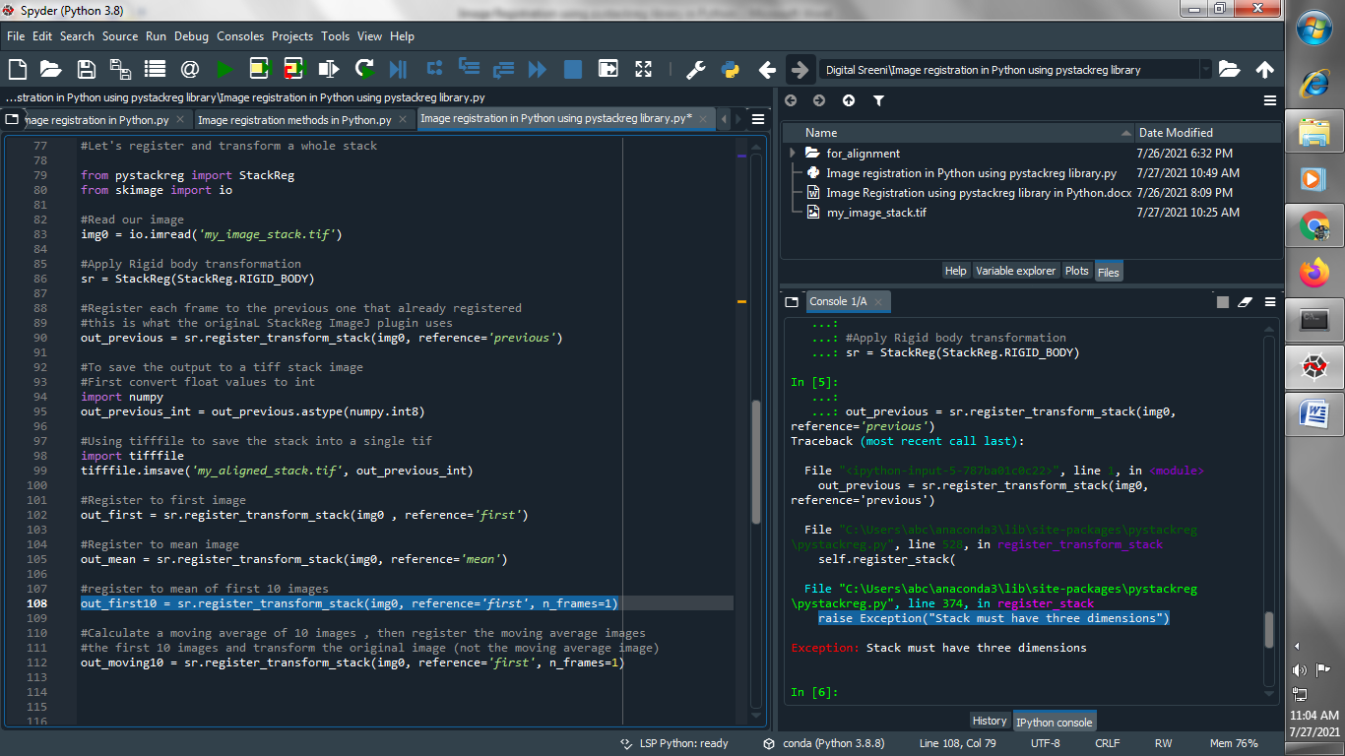

**(10) Calculate a moving average of 10 images , then register the moving average images the first 10 images and transform the original image (not the moving average image :**



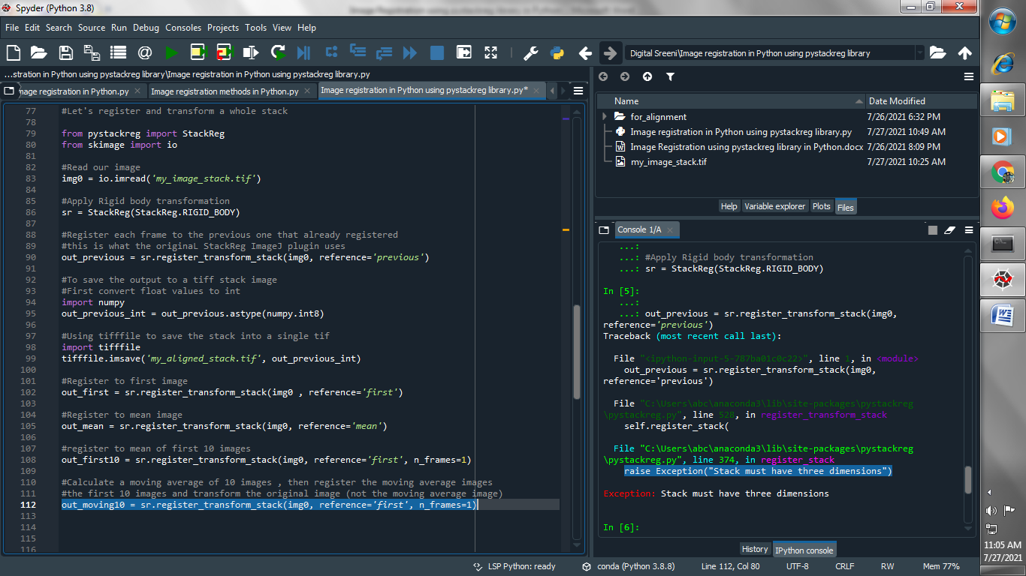

**Output :**

